Course Name: | Digital Signal and Image Processing | Semester: | VI
Date of Performance: | 25 / 03 / 26 | DIV/ Batch No: | A1
Student Name: | Aaryan Sharma | Roll No: | 16010123012

Title: Compute DFT & IDFT of 2D images using Matlab.

Objective: To learn & understand the Fourier transform operations on discrete time signals.

Expected Outcome of Experiment:

CO | Outcome
CO3 | Analyze signals in frequency domain through various image transforms

Books/ Journals/ Websites referred:
- http://www.mathworks.com/support/
- www.math.mtu.edu/~msgocken/intro/intro.html
- www.mccormick.northwestern.edu/docs/efirst/matlab.pdf
- A.Nagoor Kani “Digital Signal Processing”, 2nd Edition, TMH Education.

Pre Lab/ Prior Concepts:
Implementation details along with screenshots:
Given a sequence of N samples f(n), indexed by n = 0..N-1, the Discrete Fourier Transform (DFT) is defined as F(k), where k=0..N-1:
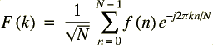
F(k) are often called the 'Fourier Coefficients' or 'Harmonics'.
The sequence f(n) can be calculated from F(k) using the Inverse Discrete Fourier Transform (IDFT):
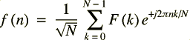
In general, both f(n) and F(k) are complex.
Annex A shows that the IDFT defined above really is an inverse DFT.
Conventionally, the sequences f(n) and F(k) is referred to as 'time domain' data and 'frequency domain' data respectively. Of course there is no reason why the samples in f(n) need be samples of a time dependent signal. For example, they could be spatial image samples (though in such cases a 2 dimensional set would be more common).
Although we have stated that both n and k range over 0..N-1, the definitions above have a periodicity of N:
So both f(n) and F(k) are defined for all (integral) n and k respectively, but we only need to calculate values in the range 0..N-1. Any other points can be obtained using the above periodicity property.
For the sake of simplicity, when considering various Fast Fourier Transform (FFT) algorithms, we shall ignore the scaling factors and simply define the FFT and Inverse FFT (IFFT) like this:
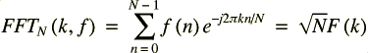
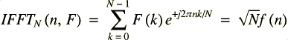
In fact, we shall only consider the FFT algorithms in detail. The inverse FFT (IFFT) is easily obtained from the FFT.
Implementation steps with screenshots for DFT and IDFT:
clc;
clear;
close all;
img = imread('image.jpg');

if size(img,3) == 3
img = rgb2gray(img);
end

img = double(img);

figure;
imshow(uint8(img));
title('Original Image');
F = fft2(img);

F_shift = fftshift(F);

magnitude = log(1 + abs(F_shift));

figure;
imshow(magnitude, []);
title('Magnitude Spectrum');

% Step 8: Phase Spectrum
phase = angle(F_shift);

figure;
imshow(phase, []);
title('Phase Spectrum');
F_ishift = ifftshift(F_shift);
img_back = ifft2(F_ishift);
img_back = real(img_back);
figure;
imshow(uint8(img_back));
title('Reconstructed Image (IDFT)');
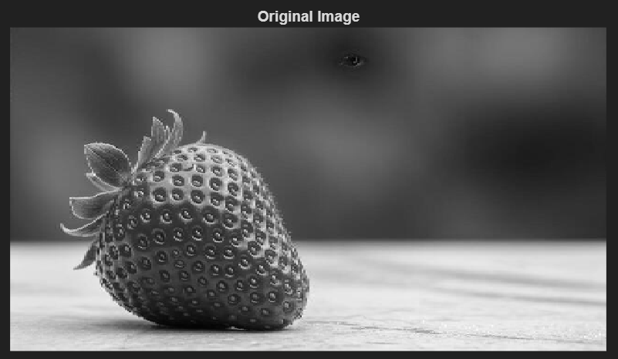
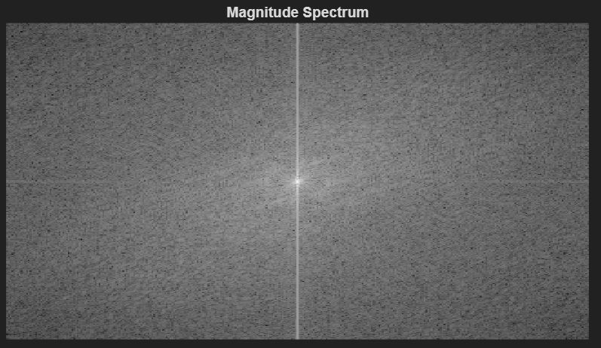
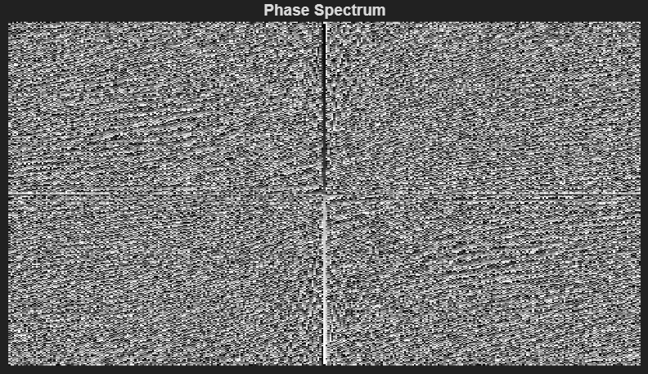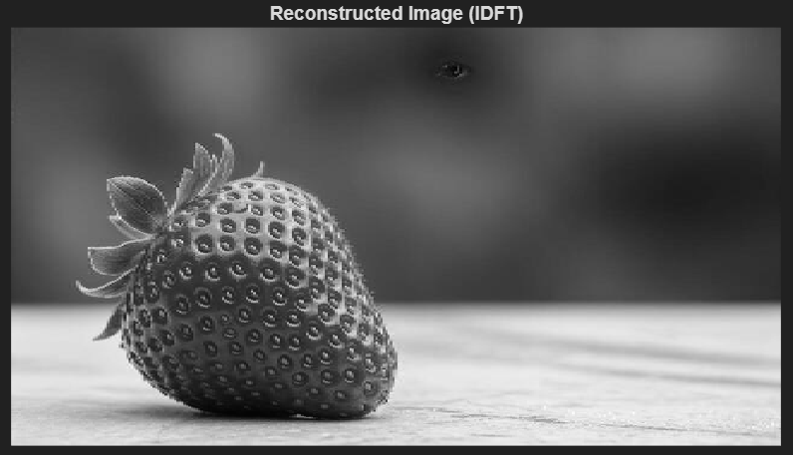
Conclusion:
In this experiment, I computed the Discrete Fourier Transform (DFT) and Inverse Discrete Fourier Transform (IDFT) of a 2D image using MATLAB. I analyzed both magnitude and phase spectra to understand frequency domain representation. The reconstructed image closely matched the original, verifying the correctness of IDFT. This experiment helped me understand the importance of frequency domain analysis in image processing and enhancement.
Date: 25 / 03 / 26 Signature of faculty in-charge
Post Lab Descriptive Questions
- Compare and discuss the computational efficiency of DFT and FFT
Feature | DFT | FFT
Complexity | O(N²) | O(N log N)
Speed | Slow | Fast
Computation | Direct calculation | Optimized algorithm
Use | Theoretical understanding | Practical implementation

- Give the properties of DFT and IDFT.
IDFT reverses DFT and reconstructs the original signal.
• Linearity
• Time shifting
• Frequency shifting
• Convolution property
• Periodicity
• Symmetry
• Parseval’s theorem (energy conservation)
- Discuss the impact on computation time & efficiency when the number of samples N increases.
• DFT computation time increases quadratically (N²)
• FFT increases logarithmically (N log N)
• Larger N → higher accuracy but more computation
• FFT is preferred for large signals/images
- How to compute maximum length N for a circular convolution using DFT and IDFT?
For two sequences of length:
x(n) → length = N
h(n) → length = M
Maximum length required: L = N + M – 1
To avoid aliasing in circular convolution, DFT size must be:
DFT length ≥ N + M − 1

